Unit 361 Webmaster

## webmaster@denverbridge.org

# I. Maintain website

In general, be aware of what’s going on in the unit and how you may need to update the website accordingly. For example:

* A club moves or changes ownership
* You get photos of event winners
* The board changes the structure of the mentor program

Below are some more specific tasks.

***General tip for website content***

Sometimes you may update the content but the change doesn’t show up. This frequently happens when you’re updating a flyer. ALWAYS verify the content and the links. If the change doesn’t appear, flush the cache on the Godaddy server.

To flush the cache, from the WordPress dashboard, open the Managed WordPress menu at the top, and click **Flush Cache**.

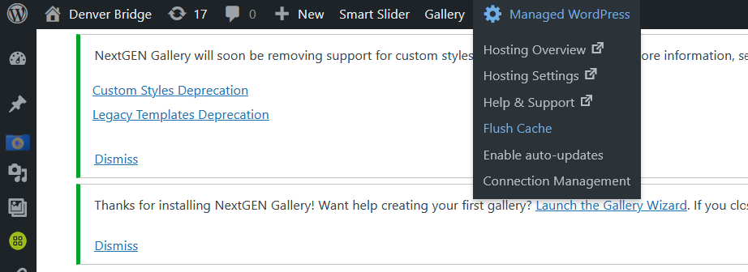

## Admin

Update the website contact info on GoDaddy.

Keep an eye on our account. As of 2022, there shouldn’t be any need to pay anything for several years, but when the time comes, check with the board, then pay with your own credit card and get reimbursed.

Make sure that the board president has the GoDaddy login, password, customer number, and PIN. If you change these, let the president know immediately.

## Statistics

At the beginning of each month, create a website usage report for the previous month and send it to the board.

## Security

The website is using the All-in-One WP Security plug-in. This may or may not be sufficient.

It is also using Black Hole for Bad Bots. This may be unnecessary given the other security plug-in.

The website is also using an automatic backup plugin, and a staging site. Neither of these have come into play as of this writing.

## Home page

* Anything the membership should know. You get this by attending board meetings and being on the board email list.
* Announcements, links, etc. for tournaments, special events, etc.
* Every now and then, go through and remove old posts, or move them.

## Tournaments

### Schedule

Put the upcoming schedule up on the Tournament Schedule page.

As flyers become available, upload the flyer to wp-content/uploads/Flyers/xxxx where xxxx is the current year, rename the flyer as required, update the individual tournament page, and activate the link from the Tournament Schedule page.

If you find yourself uploading a corrected flyer, you must clear the cache on the website server to force your browser to get the new file. Clearing the cache on your PC will not do it.

You can also archive the .doc files of flyers on the website and provide them to board members as needed.

### Tournament results

Around the beginning of each tournament, update the Tournament Results page and create a link to the results on ACBL Live. The link is based on the tournament ID – you can see the format.

*IN tournaments:* At this time, the I/N tournament results don’t get loaded to ACBL Live for a week or so. Therefore, for these tournaments, link to the results on the Denver Metro website, assuming that the tournament was held there.

### Regional bulletins

1. In wp-content/uploads/RegionalBulletins, create a folder for the current year.
2. Every day for which there is a bulletin, upload the bulletin PDF to the new folder.
3. Update the Tournaments/Daily Bulletins page, and add a link to the bulletin PDF.

### Winners gallery

Upload the photos and supply names. If you want to use a slider, I recommend Depicter, which is already installed.

### Regional speakers

Create a display for the speakers at the regional tournament, with their pictures, bios, and topics.

## Directory

Sometime after the beginning of the month, when ACBL has updated the masterpoints:

1. Get a new roster from the ACBL, in CSV Excel-readable format.
2. Upload it to wp-content/uploads/Directory.
3. Clear the cache on the server.
4. Test.
5. In the code on the Directory page, update the Roster Date value.

Maintain the exceptions.csv file as required. This file lists any changes or additions to be made to the roster we receive from the ACBL. Download the current file, make the changes on your computer, then upload the updated file and test. You may need to clear the cache on the server to get the system to read the updated file.

## Table Talk

Upload the latest Table Talk in PDF format to wp-content/uploads/TableTalk. This folder is set up to automatically display all the PDF files in it. Rename the file as required to match the existing TableTalk file names.

## Board members

Using the table plugin, keep the list of board members and roles up to date.

## Minutes

In wp-content/uploads/BoardMinutes, create a folder for the current year.

Wait until the minutes have been approved, rename the minutes files to match the existing files, then upload to wp-content/uploads/BoardMinutes, and also to the current year folder. Upload both the PDF and the .doc file.

The Minutes page is set up to automatically display all the files in the BoardMinutes folder.

At the end of the year, remove all the “old” year files from the BoardMinutes folder so that it will be ready for the new year.

## Jan Janitschke Award

If this award stays as is (as of 2022), work with the committee to determine when to open the website for nominations, and update whatever needs updating.

Before you turn things on, clear out the previous year’s responses from the nomination form.

## Registration for Pro/Am game and IN tournament

There are two registration forms on the website: one for the Pro/Am game at the regional and one for IN tournaments. At some point in the calendar, you will need to update these forms and activate the pages they’re on. Depending on the email situation, you may also need to download and disstribute submissions on a regular basis, as we have been having trouble with emails from the website.

Before you turn these on, clear out the previous year’s responses.

## Clubs and teachers lists

These lists are built from .csv files located in wp-content/uploads/BoardProcedures/40_Clubs and Teachers. To update a list, download the .csv file, make the required changes, and upload the changed file.

To update the club map, use the Google maps feature.

# II. Maintain denverbridge.org email forwarding

GoDaddy gives us 100 free email forwarding addresses. As board members change, keep these updated. You can add new ones as needed.

NOTE: These only receive and forward email – they cannot send email.

# III. Maintain board members and roles on ACBL website

The ACBL keeps a list of the board members for each unit. Keep this up to date.

If you set yourself up as the Unit Contact for ACBL, receive and forward monthly reports.

# IV. Maintain list of gmail addresses

Several board members have chosen to set up gmail addresses to keep their board email separate from their personal email. Keep the list of the addresses and passwords, and send a copy to the board president.

You can use these gmail accounts as recipients for the GoDaddy email forwarding.

|  |  |
| --- | --- |
| **Author/Revised by** | **Date** |
| Margaret Devere | March 30, 2023 |
|  |  |
|  |  |
|  |  |
|  |  |